6.1 Door Client Design
The following figures demonstrate Client Flow chart that provides Quick understand to the client Application.
As show in Fig (6.1) there are three client modes, and these modes flow diagrams shown in Fig (6.2), Fig (6.3), and Fig (6.4).
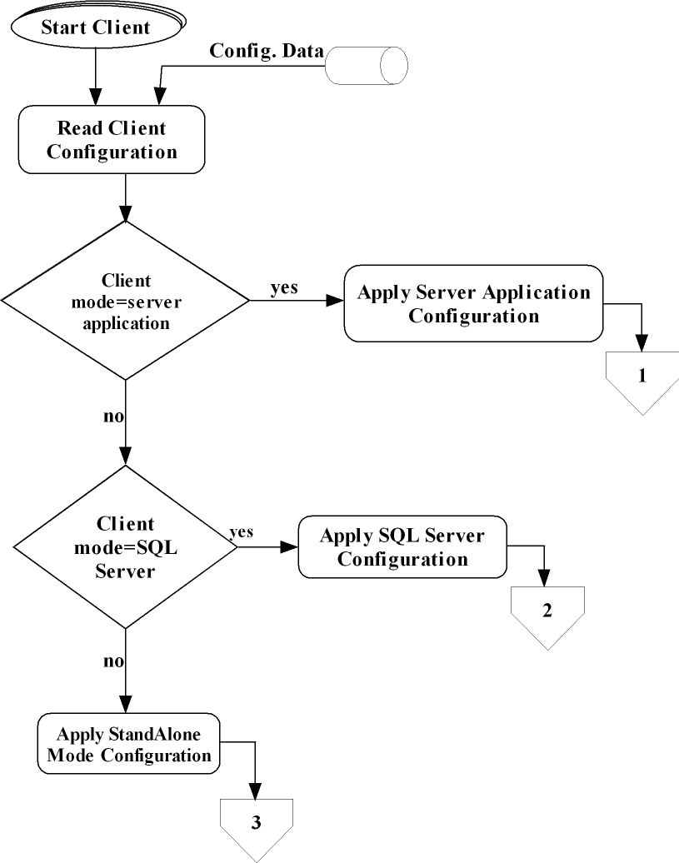
Figure (6.1): Client Flow chart part 1
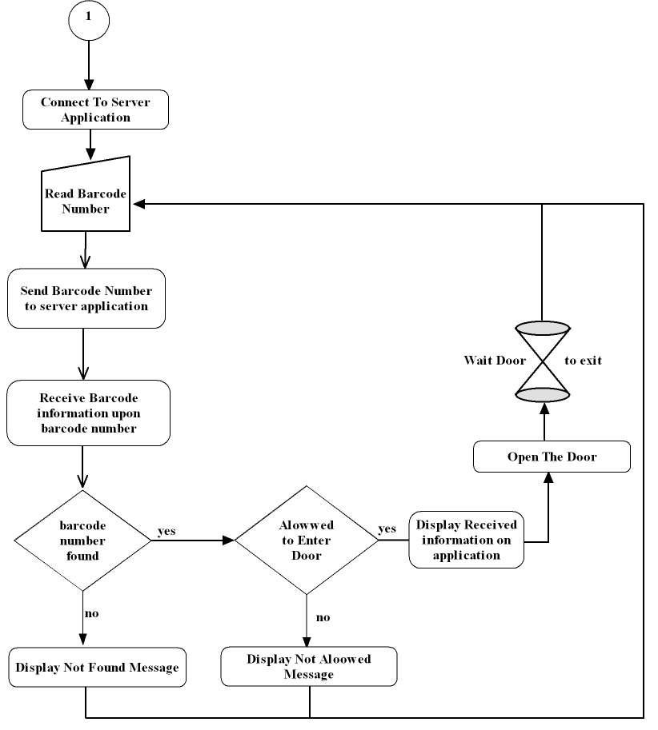
Fig (6.2) show Application flow in (connect to server application) client mode:
Figure (6.2): Client Flow chart part 2
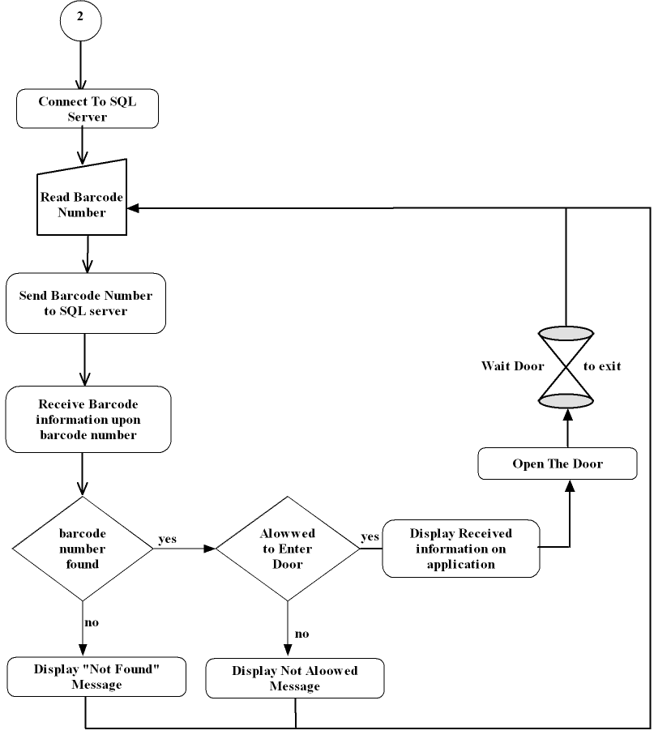
As shown here in Fig (6.3), how Application flow in (connect to SQL server) client mode:
Figure (6.3): Client Flow chart part 3
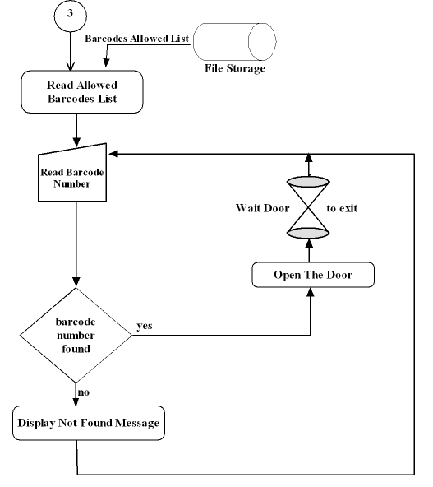
Figure (6.4): Client Flow chart part 4
6.2 Door Client Role
The basic scenario of entrance is simply student passes his student card through the card reader. The number of the card is read by the client computer using Hooking; that's how simple card readers work. The client computer checks with its own records whether this student is allowed to enter. If allowed, it opens the door lock for a few preconfigured interval of time; this event is immediately logged.
Student validity to enter door are specified by
- Sending student barcode to Centralized server(Connecting to the doors server Application)
- Searching barcode in a local prewritten list of barcodes (standalone mode)
- Sending Query to remote SQL Server where application database is attached into.
The following section discusses the Door Client Modes and how it operates.
6.3 Client modes
As maintained previously client can run either in Standalone, Connecting to Doors Server or to Remote SQL Server the following subsection provides details about each mode and how to configure the Door Application to operate under each mode.

6.3.1 Standalone mode
Standalone mode is the ordinary non-networked application mode. It is used to work during network unavailability as it has its own list of allowed students each entrance event is logged in a temporary file, and sends it later to the server once connection is available server the receives this list and insert it in the Centralized database for debugging purposes.
Standalone Mode – Can work completely by itself (but management is inconvenient) i.e., you can run it in 'standalone mode' (without core server present).

Configuring Door Client to run in Standalone mode
Start the Config.exe you can see GUI like Fig (6.5) type the correct password (initially is "DEFAULT", you can change it later once you login)
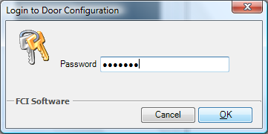
Figure (6.5): Logging into Door Configuration
After the successful login you can see the entire Door Configuration GUI appears as shown in Fig (6.6).
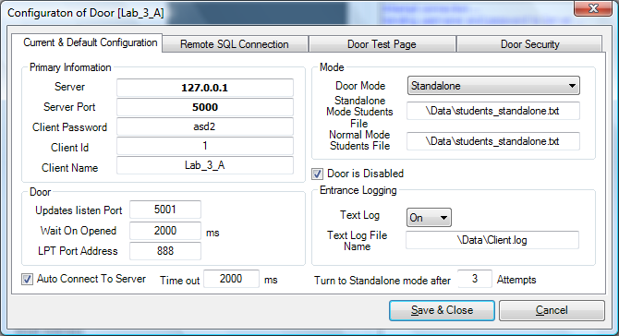
Figure (6.6): Door Configuration

To configure Door to run in standalone mode from the "Door Mode" drop down menu Select "Standalone" also set "Text Log" to "On" to log entrance attempts in the file name specified in "Text Log File Name". Don’t forget to add the barcodes that is allowed to enter door in the file name specified in "Standalone Mode Students File" as shown in Fig (6.7).
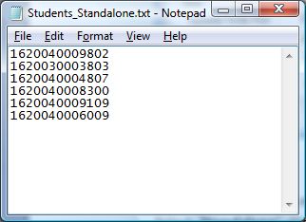
Figure (6.7): The Manual Entry of Allowed barcodes numbers.
Standalone mode can also be used as a Temporary mode in case of network unavailability to do so you have to
- Set "Door Mode" To "Connect to Doors Server".
- Check The" Auto Connect Label" ,
- Specify the time out between each attempt to connect in the "Timeout" Text Field and ,
- Specify the number of attempts after which the Door Application will turn to Standalone mode the "Turn to Standalone mode after"
- Press "Save&Exit" you will be notified that changes will not take affect until application restarts.
Figure 6.8 Shows the Doors application that operates in Standalone mode.
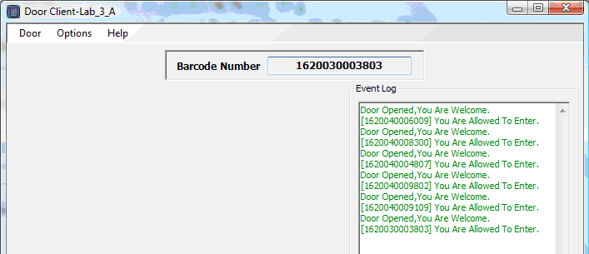
Figure (6.8): The Door Client in the standalone.

Fig (6.9) shows the Door Client working after network unavailability event detected.
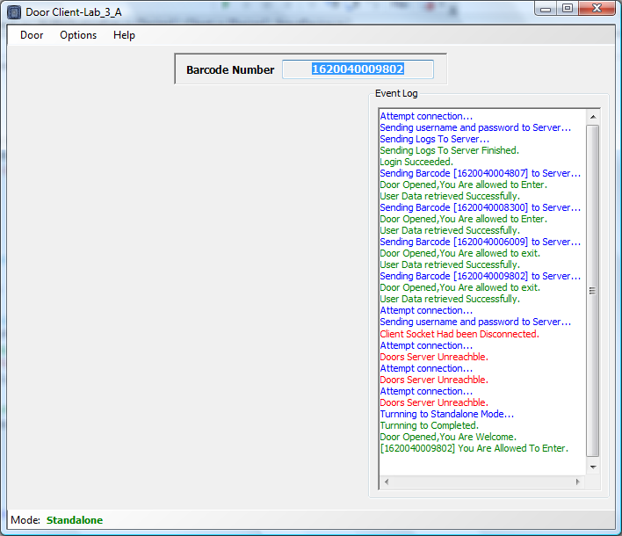
Figure (6.9): The Door Client turned to standalone mode.
Note that in this case logs are written in the specified log file (if this feature enabled) once connectivity returned log file is sent back to server to be appended in the logs table in the database.

6.3.2 Connected to SQL server
SQL Server 2005 supports several methods of communication between client door applications and the Centralized database Fig (6.10). Client door applications submit database requests to the server using SQL statements. After it is received, the SQL statement is processed SQL Server, and the results are returned to the client door application when the application is on the same computer as an instance of SQL Server 2005, Windows Interprocess Communication (IPC) components, such as Local Named Pipes or Shared Memory, are used. When the application is on a separate client, a network IPC, such as TCP/IP or Named Pipes, is used to communicate with SQL Server. SQL Server uses a dynamic link library (DLL), called a Net Library, to communicate with a particular network protocol. A matching pair of Net Libraries must be active on both client door and server door computers to support the desired network protocol. For example, to enable a client application to communicate with a specific instance of SQL Server across TCP/IP, the client TCP/IP Sockets Net Library (DBNETLIB.dll) must be configured to connect to that server on the client computer, and the server TCP/IP Sockets Net Library (SSNETLIB.dll) must be listening on the server. Also in this case the TCP/IP protocol stack must be installed on both the client and server computers
After installing SQL Server 2005, you need to define the behaviors of the client Net Libraries by using the Client Network Utility and server Net Libraries by using the Server Network Utility.
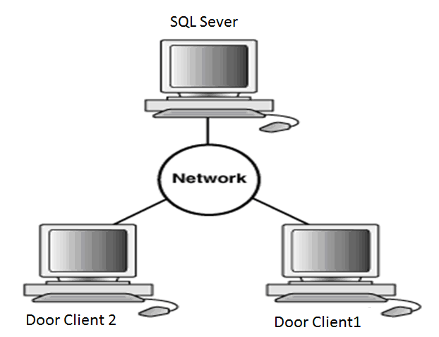
Figure (6.10): Communication Fashion between SQL Server and Door Clients.
Configuring Door Client to run in Remote SQL Connection mode
Referring to Fig (6.6) set the "Door Mode" to "Remote SQL Connection" and open the "Remote SQL Connection" Tab as shown if Fig (6.11).

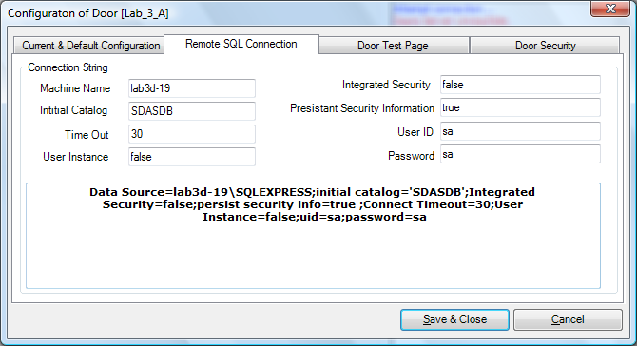
Figure (6.11): Remote SQL Configuration Tab Page.
Basically each place the connection string in the wide provided area or fill each property separately. Fig (6.10) shows the connection string that is currently used by application, note: before using it don’t forget to change the server name to your server name.
Fig (6.12) Shows Application running in this mode.
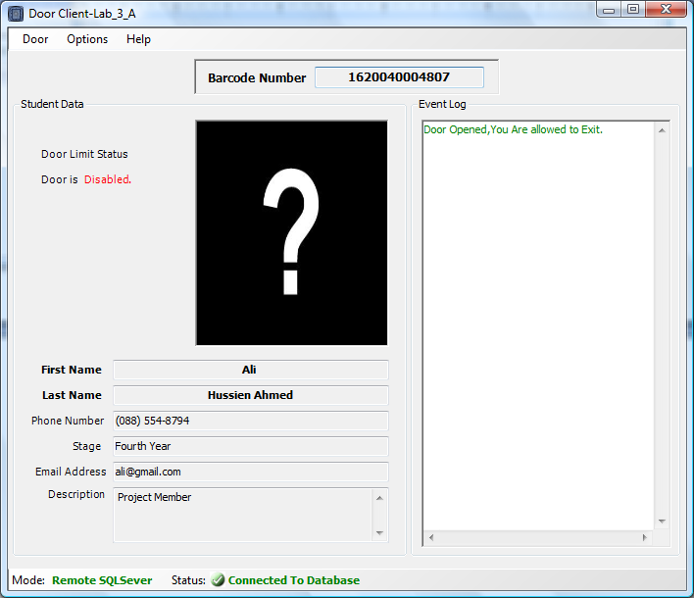
Figure (6.12): Doors Client Connected to Remote SQL Server after successful request Processing

6.3.3 Connected to server application
Client door applications are not responsible for performing any data processing. Rather, they request input from users, request data from the doors server, and then analyze and present this data using the display capabilities of the client workstation or the terminal. It is also not dependent on the physical location of the data. Even if the data is moved or distributed to other database servers, the application continues to function with little or no modification. Client workstations or terminals can be optimized for the presentation of data (for example, by providing graphics and mouse support), and the server can be optimized for the processing and storage of data (for example, by having large amounts of memory and disk space).

Figure 6.13 shows the basic Schema of Doors Server Connected with some door Clients.
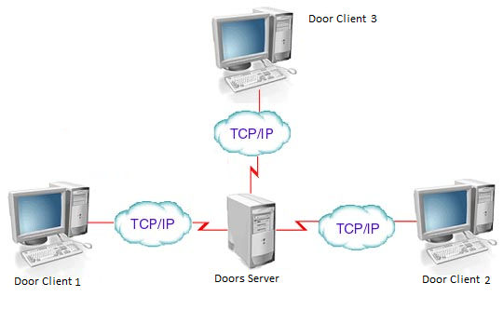
Figure (6.13): Communication fashion between servers and doors Client
In networked environments, shared data is stored on the database servers rather than on all computers in the system. This makes it easier and more efficient to manage concurrent access.

6.3.4 Configuring Door Client to Connect to Doors Server
Returns to Fig (6.6) just write the Doors Server IP Address in the "Sever" text field and so the "Server Port", door name, password and ID, set the "Door Mode" to "Connect to Doors Server" and restart Application.
Figure 6.14 shows successful login to server
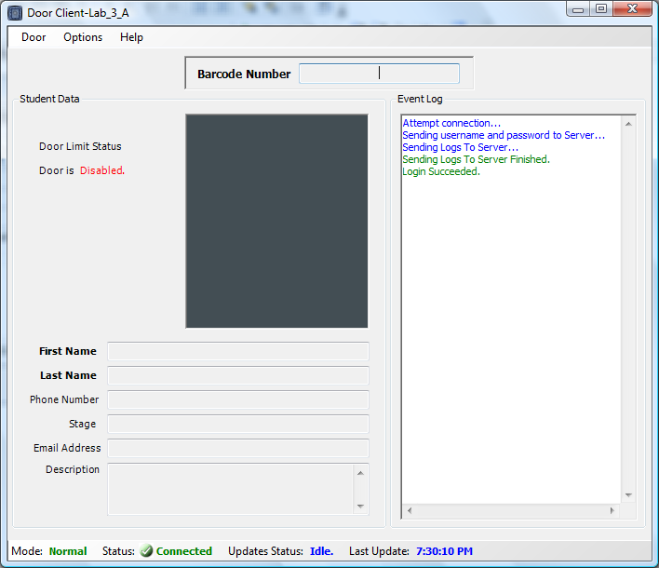

Figure (6.14): Successful client Login
Fig (6.15) shows invalid login to server, in this case server immediately disconnects door socket

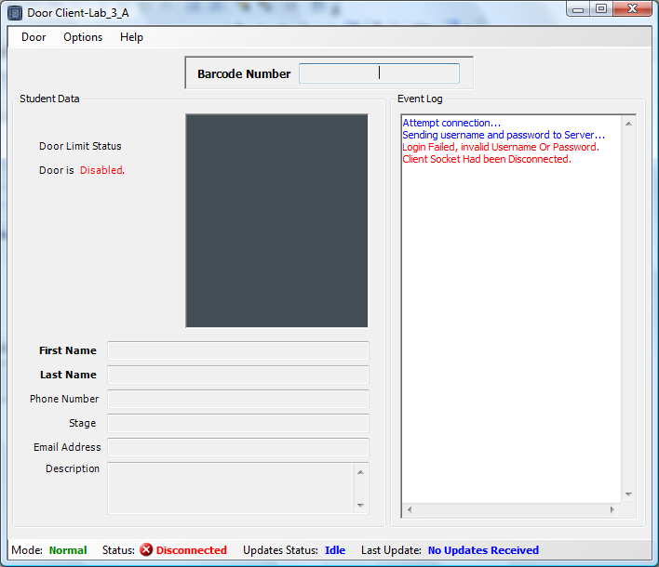
Figure (6.15): shows invalid login operation

Once client successful login client can easily send barcodes and receive replay from server Fig (6.16) shows basic client server interaction
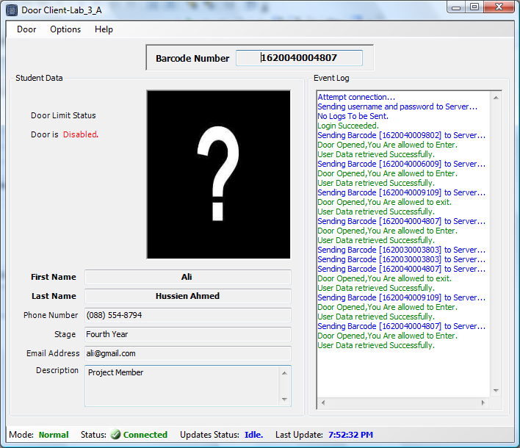
Figure (6.16): Client Server interaction
6.4 Other Door client configuration

Referring to Fig (6.6)

- "LPT Port Address" For communicating with the door locks control.

- In the Doors test page tab page Fig (6.17) you can test and adjust door pins that are connected to the door, open and close door.

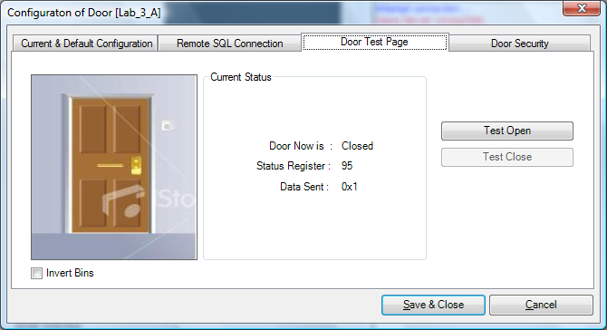
Figure (6.17): Manual Door test Page
- Finally to the Door Security tab page Fig (6.18) you can use it to change the configuration login password don’t worry the password is encrypted and saved in the specified file name by Rijndael Symmetric Encryption algorithm.
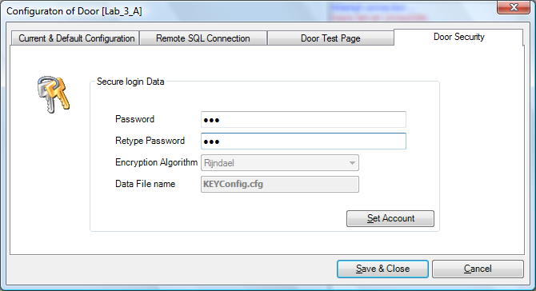
Figure (6.18): Door security tab page
6.4.1 Configuration Security
The application provides secured configuration file that is only accessed by a program with secured password, the cause of this is using encryption in encrypting both configuration and the password this to preserve configuration integrity and accountability.
Encryption key is embedded in the code, used with the Rijndael Symmetric algorithm provides powerful configuration protection.

6.4.2 Updates
Client has a list of the student that allowed entering the lab, this list must be updated every few minutes, so once client connected to server, and it sends it a list of the latest students allowed. Also this list is sent every few minutes; it will be used in case of standalone mode (if configured).

6.4.3 Entrance logging
System logs any attempt to enter the Door, whether the door was unlocked or not. The client computer saves all log events to a file on its hard drive immediately after the event occurs. Clients send the server logs of entrances, and the server saves them in its database. A client can be set to report entrances immediately, or to store a log of entrances until the server initiates a connection. Once client connects to server it transmits the log file and finally clears it. The server saves the events from the log file to its database. Clocks on all the computers should be set to the correct time in order for the logs to show right timestamps, because the server must trust the clients to write a correct timestamp on each event in the log file.

